Installation Manual

This guide has been written to support the setup and installation of the customisable online store application.

# Compatibility

## Server Software

The application was developed using a XAMPP/1.8.2 web server running;

* Apache/2.4.7
* MySQL/5.5.36
* PHP/5.4.25

Therefore, to install this product it is expected that the intended server will have at least these versions or later of the required software installed.

## Verified Compatible Browsers

The application has been verified as compatible with latest versions of the five most popular web browsers. It is possible that the aesthetics (CSS) of the website will be rendered slightly different across the browsers, particularly in Internet Explorer.

|  |  |
| --- | --- |
| Browser | Verified Version |
| Google Chrome * | 42.0 |
| Internet Explorer ** | 10.0 |
| Mozilla Firefox | 36.0.1 |
| Opera | 28.0 |
| Safari | 5.1.7 |

**\*** Recommended browser ** Images are rendered differently, not recommended

# Installation Steps

|  |  |
| --- | --- |
| Step | Description |
| 1 | Copy the root product folder named ‘678526’ to the required location on your web server. (If using XAMPP, the ‘htdocs’ folder.) |
| 2 | Navigate in the file system to ‘678526/inc/config’ and confirm ‘config.php’ does **not** exist. If ‘config.php’ does exist, delete it. |
| 3 | If desired, you can rename the root product folder (678526) to a more appropriate name.  ***(optional)*** |
| 4 | Ensure your web server is running. (In XAMPP this typically can be checked by navigating to ‘localhost’ in your browser.) |
| 5 | In your browser (Google Chrome is recommended), navigate to the product URL. This will be in the format ‘[host]/[foldername]’ or in this case ‘localhost/678526’. |
| 6 | You should be navigated to the configuration page, if not, confirm step 2. If an error still occurs, try recopying the folder and starting the installation steps again. |
| 7 | Input a name for your store and specify standard delivery charge. Delivery charge must be in the format ‘0.00’. Click ‘Setup’.  *At this point, the database is created if it does not already exist. Default database login credentials are; HOST = ‘localhost’, USERNAME = ‘root’ and PASSWORD =’’*. |
| 8 | Your browser should now take you to the Content Management System for your online store. Please refer to the user manuals for help regarding the CMS pages. |

User Manuals

# Content Management System (CMS)

## Summary

The CMS facility allows the user to manage the product inventory, manage product categories, add delivery charges and specify the colour scheme of the online store.

The CMS facility is accessed via ***[host]/[productfolder]/cms*** in the browser.

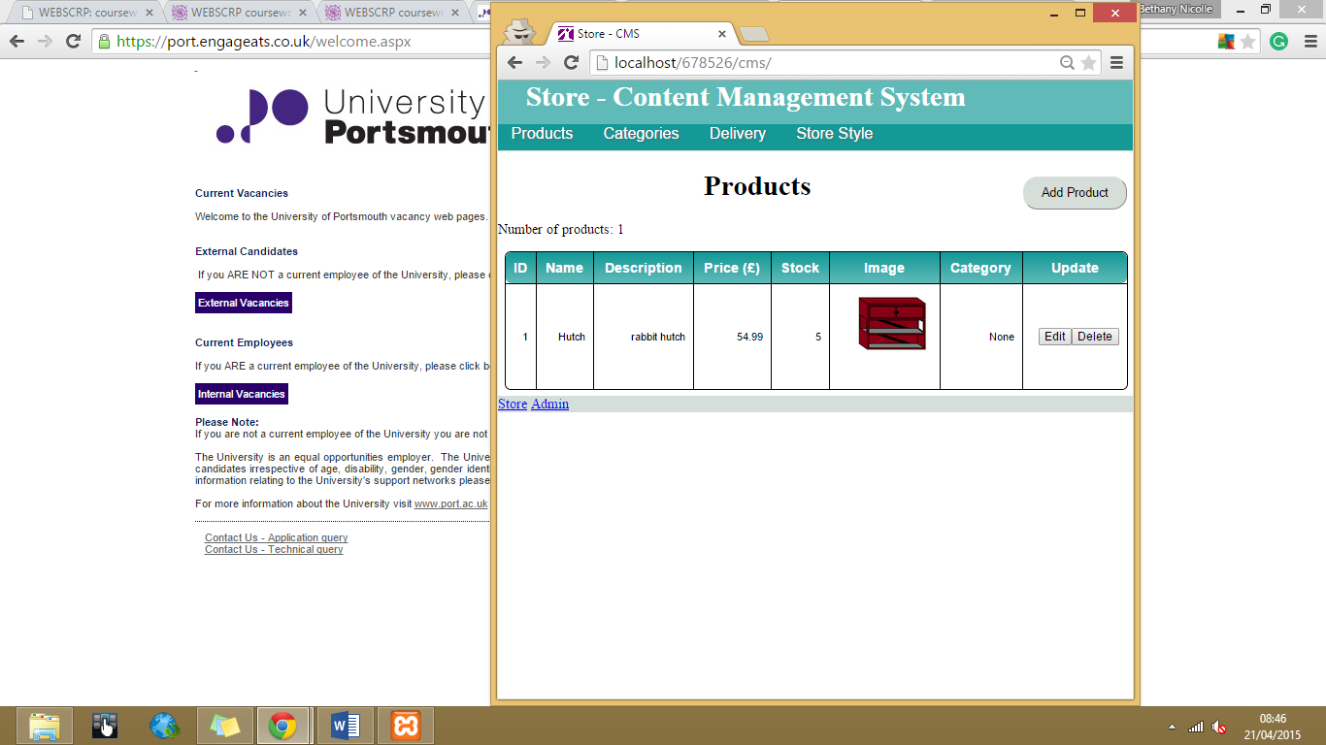

CMS navigation options

## Products

Click here to add a new product to the store.



Navigates the user to either the online store or the admin facility.

Use this to edit a products name, description, price, stock or category.

Deletes the product on that row. Product will be removed from store.

## Categories

Adds a new category. This will appear as a category on the online store.

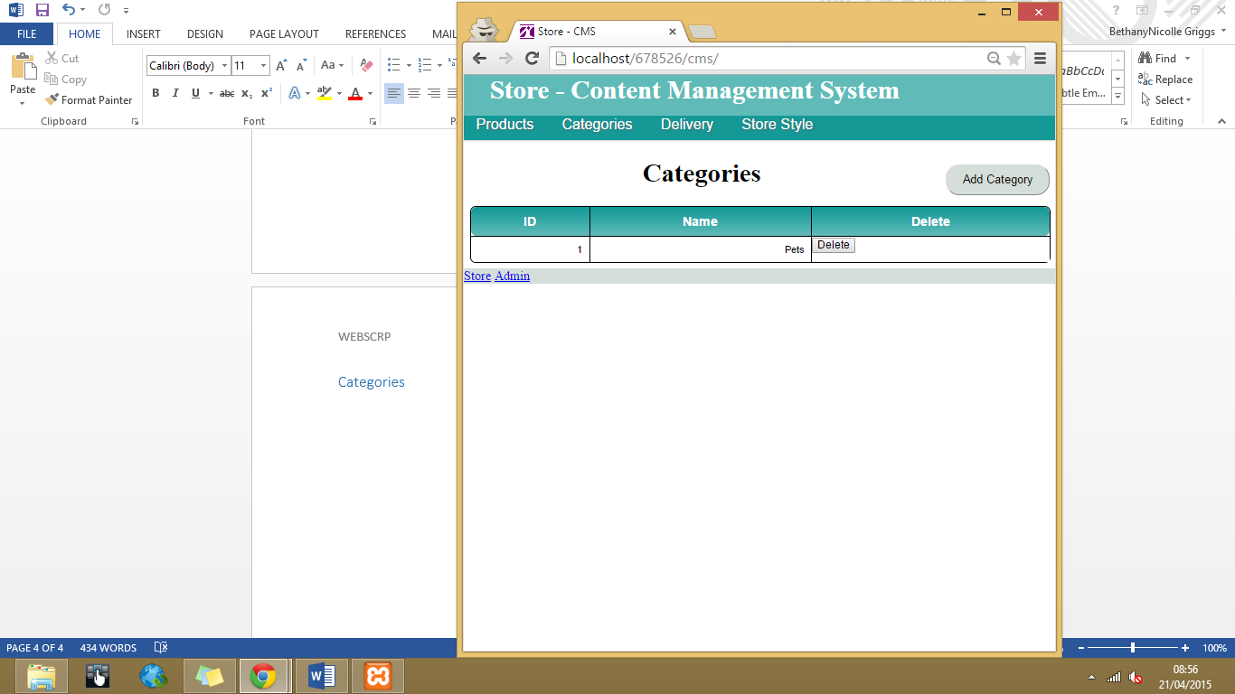

Deletes the category. All products in this category will have their category set to ‘None’.

## Delivery

Adds a new delivery method.

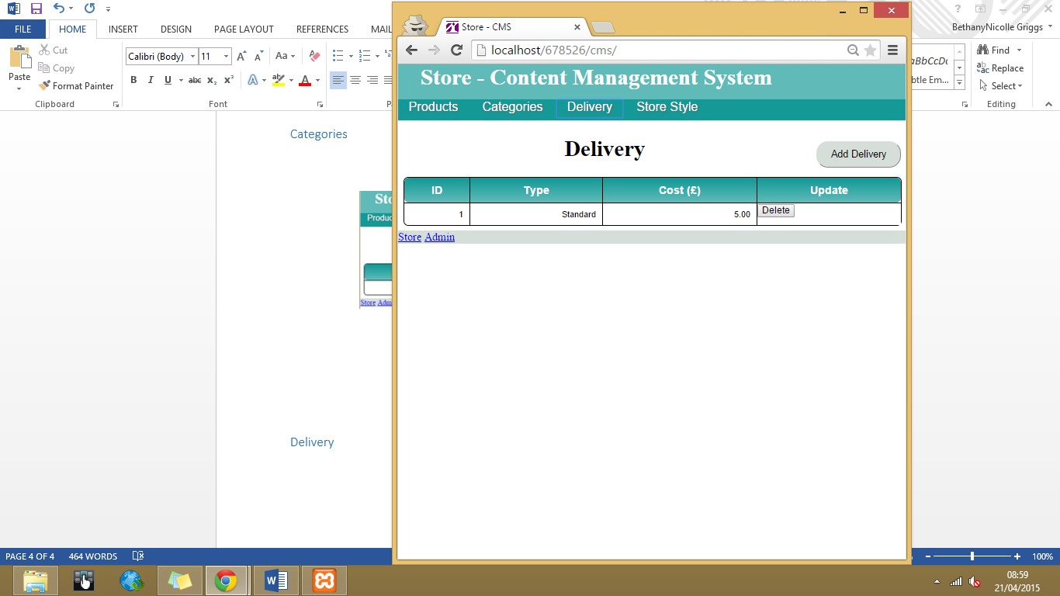

Removes the current delivery method.

Note: Customers will not be able to submit their orders without a delivery method.

## Store Style

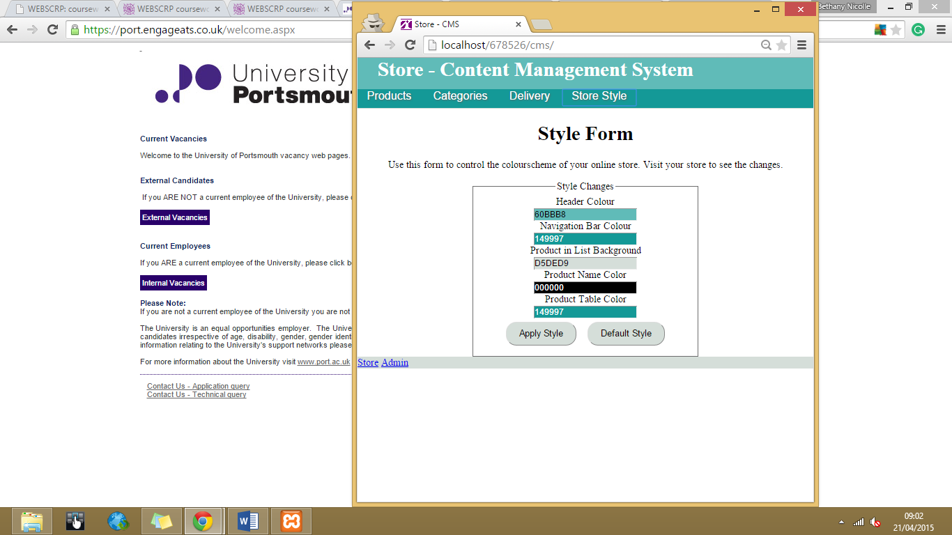

Applies the selected style to the online store, visit your store to see changes.

Resets the store to the default style.

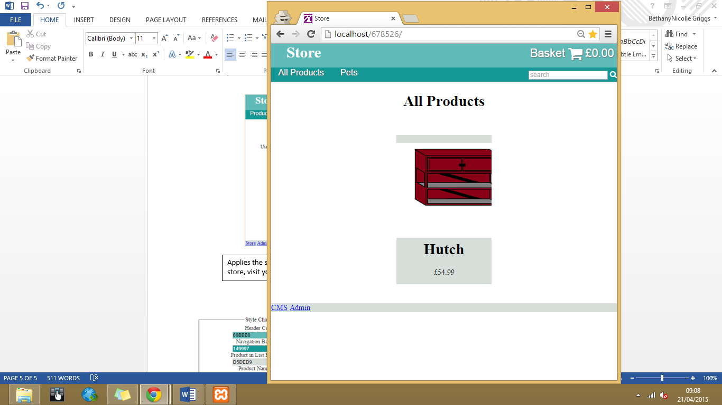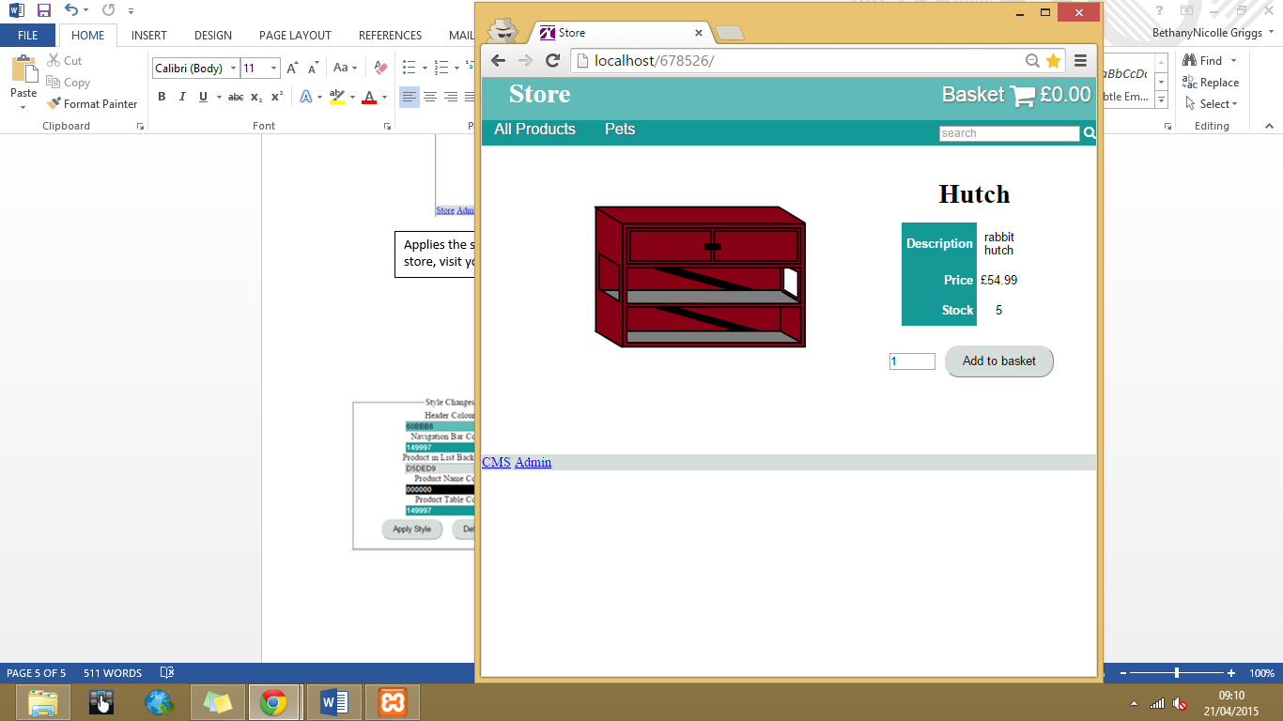



# Admin

## Summary

The Admin facility allows the user to view product stock levels, add stock, view product sales and view customer orders and invoices.

The Admin facility is accessed via ***[host]/[productfolder]/admin*** in the browser.

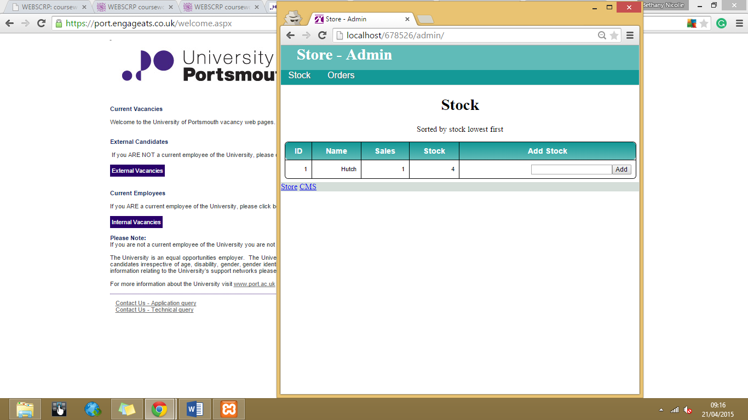

Admin navigation options

## Stock

Products are displayed in order of stock lowest to highest.



Displays product stock and sales levels.

Adds stock to the particular product.

## Orders

Total sales in period.

Allows the user to choose the date range of the orders.

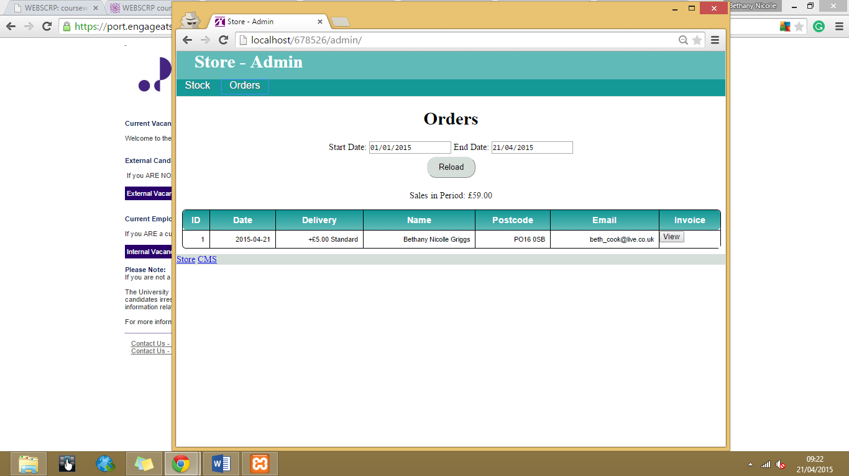

Displays order details.

View the invoice for the order.

## Invoice

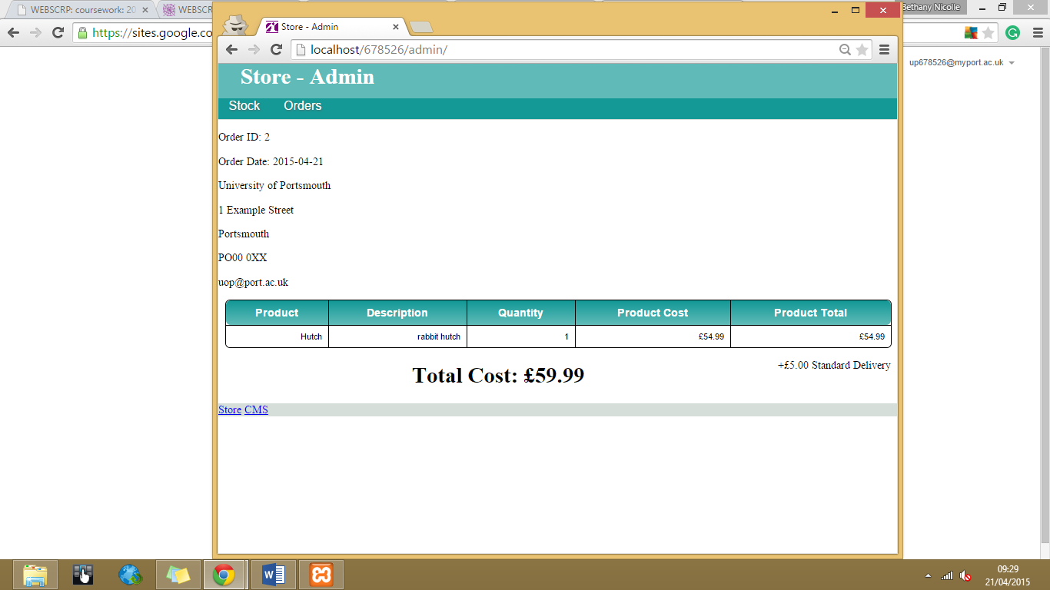

Example Invoice

# Store

## Summary

The Store facility allows the customer to view products, search products, add product to a basket and submit their order.

The Store facility is accessed via ***[host]/[productfolder]*** in the browser.

## All Products

Click here to view products in the particular category.

Click here to view products in basket.

Search facility, will display products whose name matches.

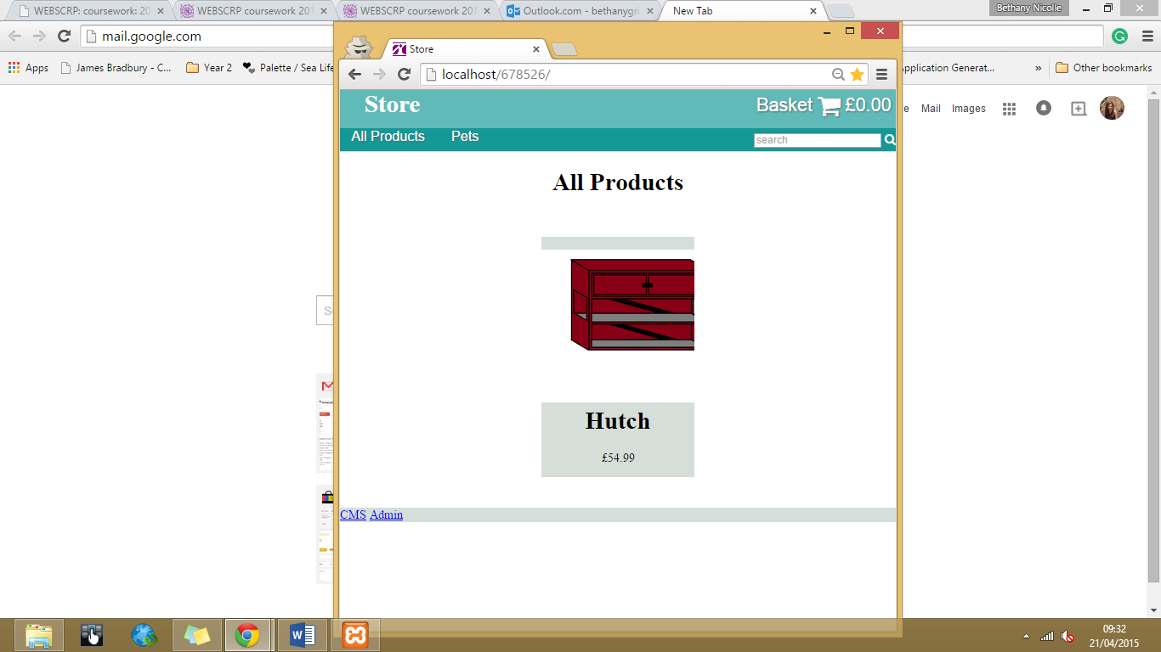

All products in the database will appear here.

Click here to view the products details.

## Product

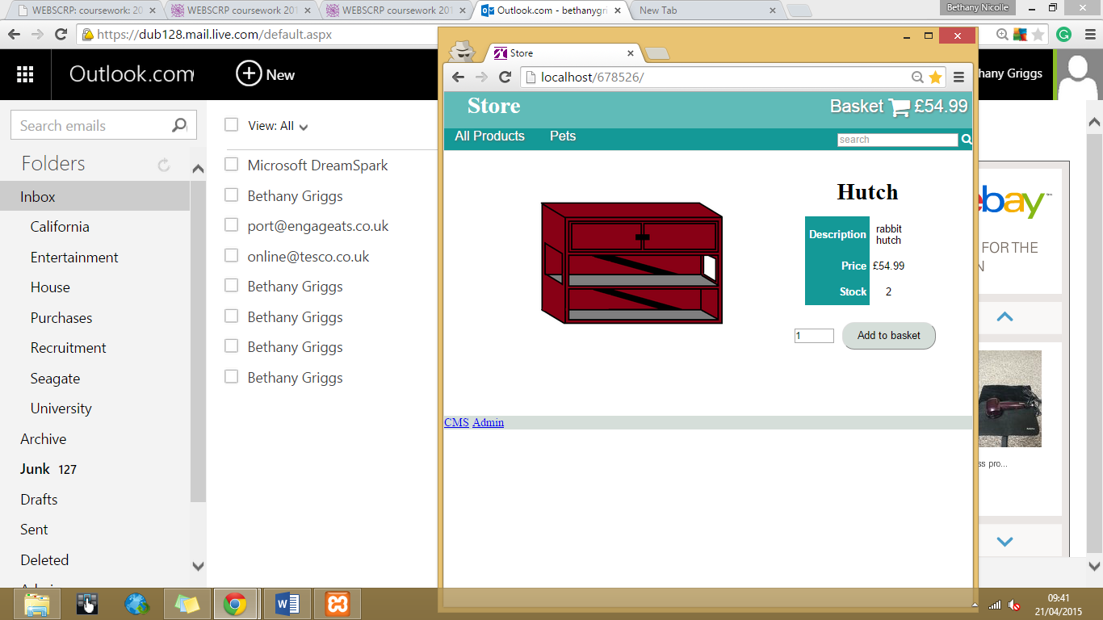

Product details.

Product image.

Adds the specified quantity to the basket.

## Basket

Shows the products in the basket.

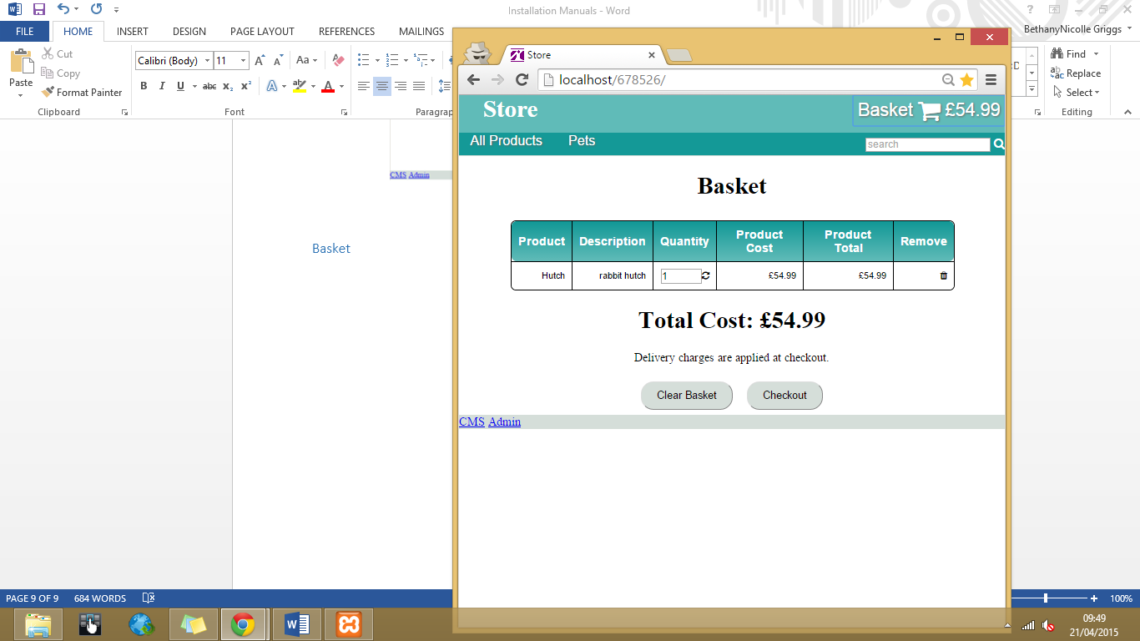

Updates the quantity in the basket.

Clears all products out of the basket.

Total cost of all products in the basket.

Removes the product from the basket.

Proceed to the checkout form.

## Checkout

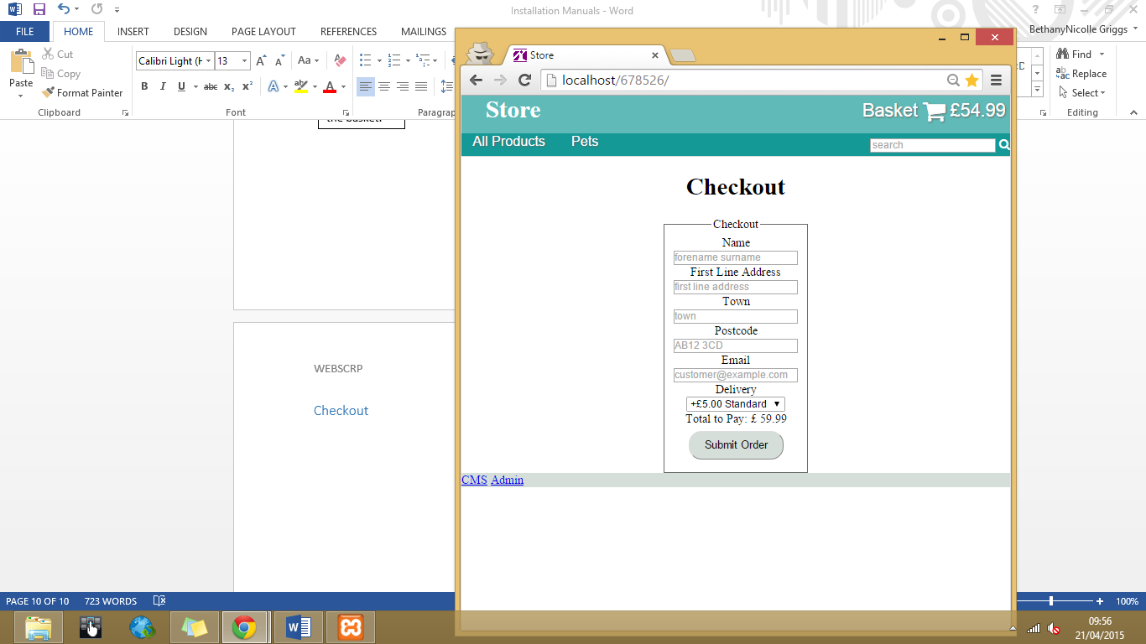

Customer and delivery details form.

Submits the order.